Living In Cities

Suraj Bitla

July 8, 2019

**Introduction**

When people try to decide where to work and or live, we face multiple choices. You may appreciate to live in metropolis like New York and Los Angeles, or you may prefer smaller but quitter cities which people may not even know their names. Conventional wisdom tells people that if you want prosperity, go to big cities because those are where opportunities lie. However, this opinion is now challenged. Planet Money got a letter from a listener named Dennis Simpson. His argument had a lot to do with where he lives - Hot Springs Village, Ark. Hot Springs Village has 9 golf courses and 11 lakes. It's got clean water and little crime or traffic. And on top of all this, Simpson says, the town is dirt cheap, especially when compared to our nation's big cities, which brings us to his argument: cities are overrated. Big cities simply aren't worth the cost.

In this project, we leverage some public data, and will try to address the problem: **Living in cities.** This project will give people some insight when they are faced with the choices of small or big cities.

**Data**

To determine if big cities are overrated, we need the following data

* basic city information e.g. population, median household income, median house price
* demographic data of ethnicity composition
* crime data
* venue data

The above data are nevertheless not exhaustive, you can come up with more data pertent to cities. We will use public data from the following sauce

* <http://www.city-data.com/>
* <https://foursquare.com/>

**Methodology**

In this section, we will do some direct comparison between data grouped by big cities and small cities. Visual plots will provide most appealing tools for people to draw conclusions.

* From city basic info data, we can get some general ideas of what lifes are like in big and small cities.
* From city race data, we can get a clear picture what are the main ethnicity groups in big and small cities.
* From city crime data, we can see the trend of crime index in big and small cities over the years.
* From the city venue data, we can see how many venues are in the downtown area since we limit the searching area to 500 meters away from city center.

**Exploratory Data Analysis**

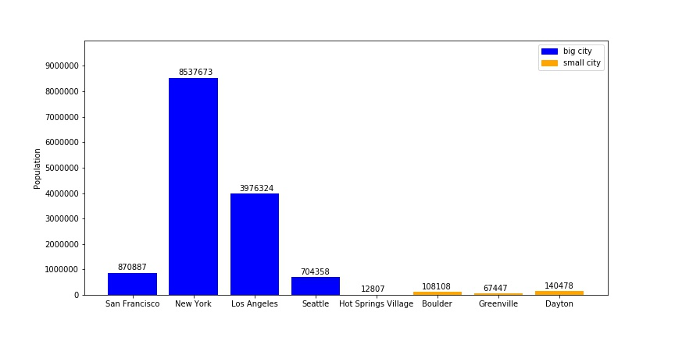

Fig. 1. Population

It can be seen the so called "big cities" are those who have population around a million or more. New York is the most populated city in the US. Small cities usually have tens of thousands of people.

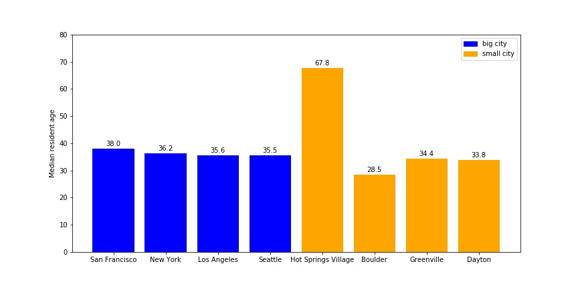

Fig. 2. Median resident age.

It might be true that people who lives in Hot Springs Village are quite old, or it might be the source of the data is not very accurate.

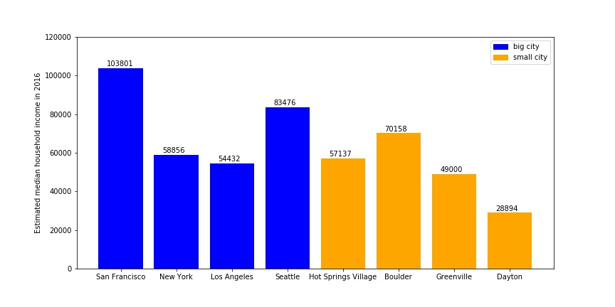

Fig. 3. Estimated median household income.

In general, big cities median household income are higher than small cities. However, there are some small cities have quite high median household income, such as Boulder. A side note: U.S. real median household income reached $61,372 in 2017, an increase of $1,063 or 1.8% vs. 2016.

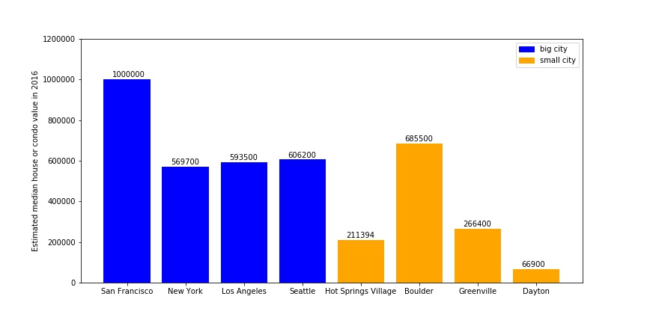

Fig. 4. Estimated median house or condo value.

San Francisco has the most expensive houses. Again, Boulder stands out in terms of housing price.

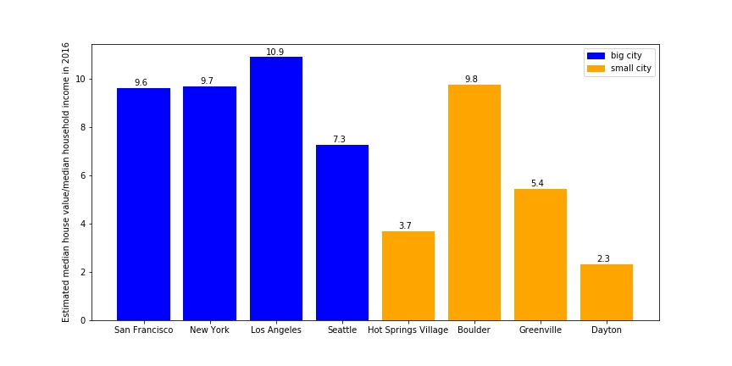

Fig. 5. Estimated median house value divided by median household income.

I think it's interesting to calculate the division of median housing price by median household income. The results sadden me because I live in Los Angeles.

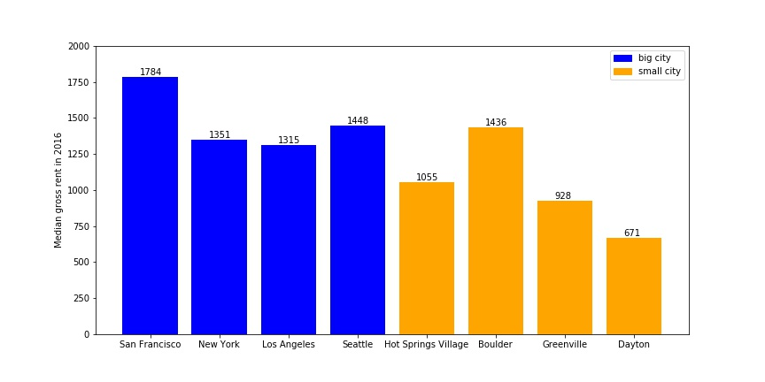

Fig. 6. Median gross rent.

San Francisco, again, claims the crown in terms of rent. Rule of thumb: Spend a fixed percentage of your income on housing. The general recommendation is to spend about 30% of your gross monthly income (before taxes) on rent.

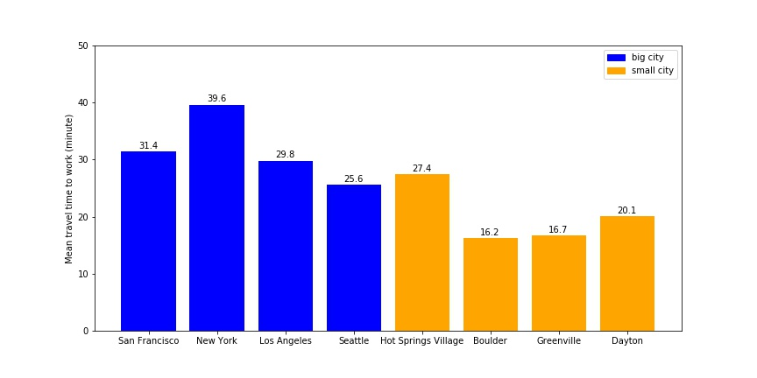

Fig. 7. Median travel time to work.

New York - Capital of traffic congestion.

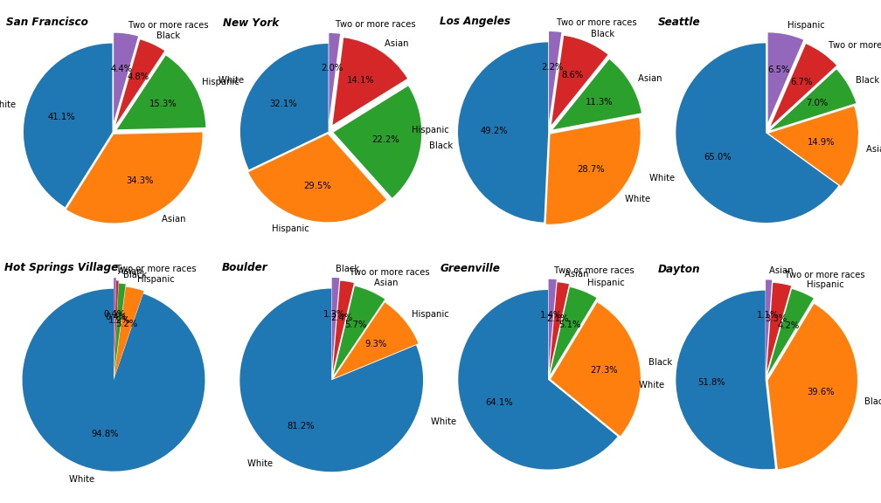

Fig. 8. Ethnicities composition, pie chart.

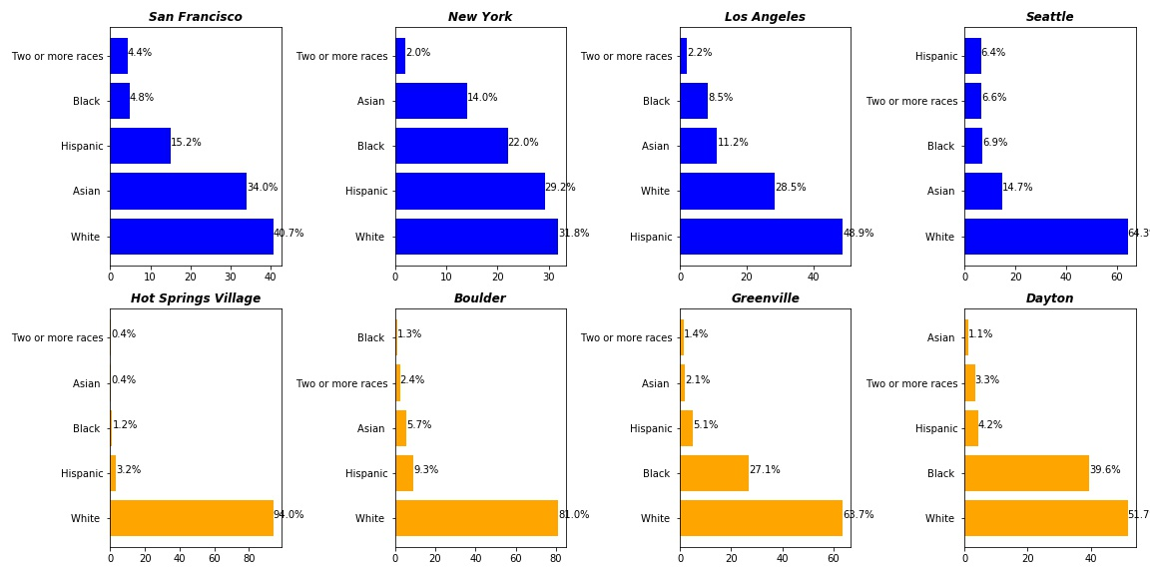

Fig. 9. Ethnicities composition, bar chart.

Cleary, big cities have more evenly distributed ethnicities, where in small cities, white people are the majority.

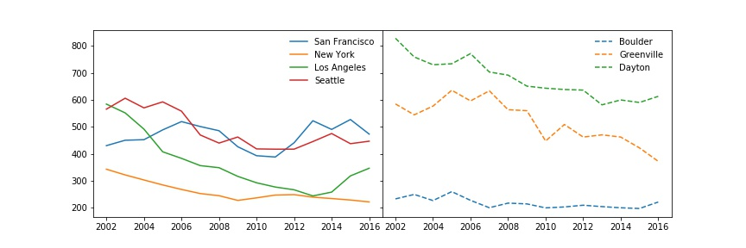 Fig. 10. Crime index from 2002 to 2016.

It's interesting to find out some small cities aren't the safest. However, I couldn't find the crime data for Hot Springs Village. Maybe its crime is minimum or just the data is missing.

Table 1. Top venues in 2016.

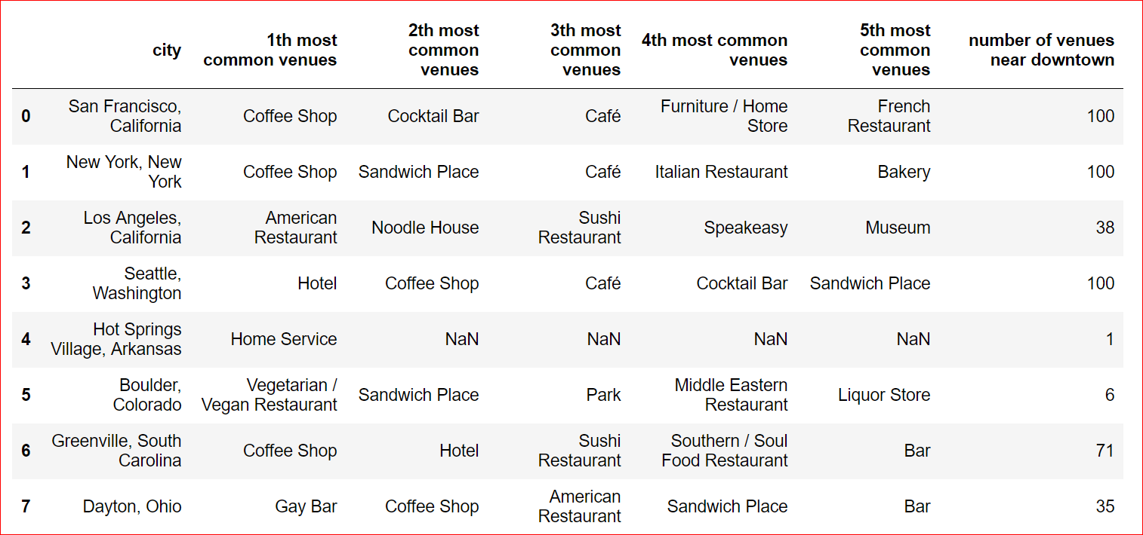

Not surprisingly, big cities have more venues near downtown area, whereas small cities have less. I just found 1 venue near Hot Springs Village!

**Results and Discussion**

From the above summary and comparison, we can see different aspects of life in big and small cities. While big cities enjoy higher income and convenience to various venues, they also suffer traffic jam and higher housing price. In comparison, small cities may have lower house hold income and less access to venues, they do have an advantage of more affordable housing and less crime.

**Conclusion:**

You should not move to big expensive cities like New York or Seattle. Instead, they say, it's actually mid-sized cities where you should go, mainly because they have a much lower cost of living. In other words, big cities are overrated.